Reed Hostetler

Unit 2 Project

**PROBLEM STATEMENT:**

Credit cards can impact different individuals in different ways, as some use it wisely and routinely pay off their balances while others spend recklessly and generate debt, thus hurting their credit scores. A direct factor of being able to pay off debt though is the amount of one's salary, as this will allow more spending on the credit card.

**PROPOSED TEST:**

This analysis tests the hypothesis that for those who have a credit card, their credit scores are positively correlated with the size of their salary.

**MEASURABLE OUTCOME:**

Using the Churn-Modeling data, I created a new SalaryBracket column coded as:

1 = Lowest Bracket ($11.58-$40,000)

2 = Middle-Low Bracket ($40,001-$80,000)

3 = Middle Bracket ($80,001-$120,000)

4 = Middle-Upper Bracket ($120,001-$160,000)

5 = Upper Bracket ($160,001-$199992.48)

I then evaluated the average credit score across these five salary brackets to test the hypothesis that the average credit score would be higher amongst the higher salary brackets. Below are the results of the analysis:

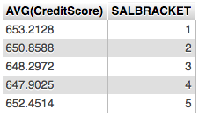

These results do not support the initial hypothesis that the estimated salary and credit score are positively correlated, as shockingly enough the lowest salary bracket has the highest average credit score. The highest salary bracket having the second-highest average credit score somewhat supports the hypothesis, but being less than the lowest salary bracket hurts the credibility of the hypothesis far more.

An additional part of the hypothesis was that the data points would have to have credit cards; otherwise there would be no debt to generate without them. I then reduced the scope of the analysis to only people with credit cards, and the results are below:

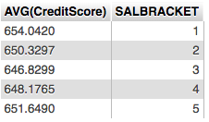

When removing people that don't have a credit card, then the lowest salary bracket even increases the difference between the next closest bracket (from 0.7614 to 2.393), which was again the highest bracket. This shows even more that the estimated salary and credit score do not have any correlation with the two highest average credit scores being from the 1st and 5th salary brackets.